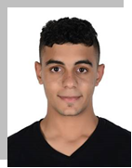Abbas Abdullah Marhoon

Personal Profile

|  |  |
| --- | --- |
|  |  |
| Nationality:  Date of Birth:  Age:  Contact: | Bahraini  18/2/2001  18 Years  Mobile: +973 38307125  E-mail: abbas29mrhcoon@gmail.com |

Objective

Seeking a position in an environment that offers a greater challenge and increase my knowledge .

Education

2016 – 2019 Secondary School Diploma

Al Noaim Secondary school

**Experince**

NO EXPERIANCE

**Other**

Computer Skills: Microsoft Office (Excel, Word, PowerPoint),

Interpersonal: Cooperative and Team worker.

Languages: Arabic and English (Excellent).

Hobbies: Swimming, Sports, Internet & Video Games

**References:** Available upon reques